HIGHPOINT’S “CHOPPO”

Choppo is a pointing machine and position himself using the wind to his advantage. Choppo’s intelligence and style makes him a go to dog given any situation. He’s a dog that can go all day, not only because he has great endurance, but his strong will power. Choppo’s the dog that will mark a dead bird an 300 yards away and you can keep moving because of his talented nose, work ethic, and love for the retrieve.

DOB: 2/12/2022
AKC #: SS32800504
OFA #:LR-279864E36M-P-VPI (EXCELLENT)
Weight: ~65 lbs

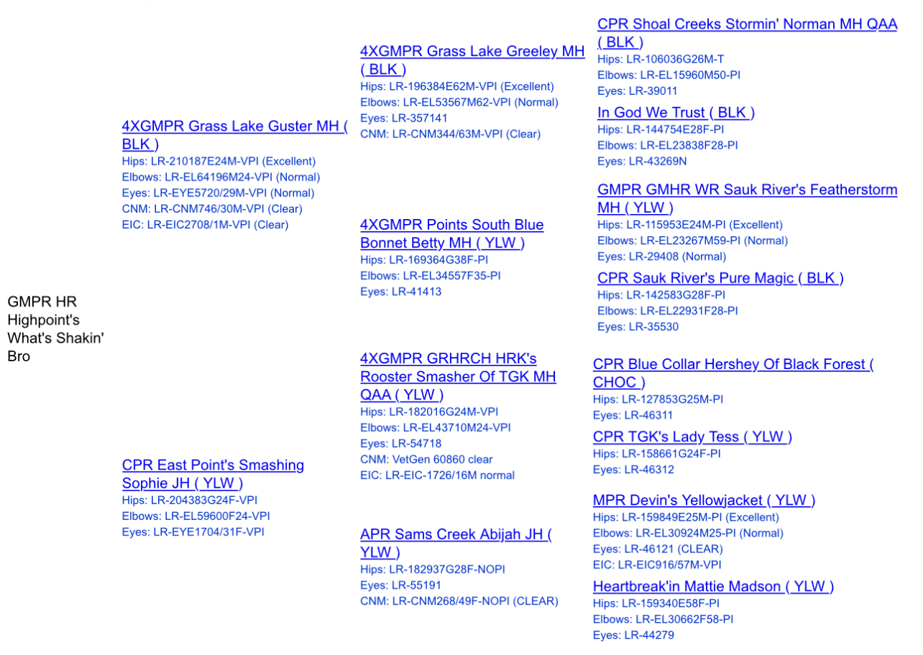
SIRE: GMPR HR HIGHPOINT’S WHATS SHAKEN’ BRO

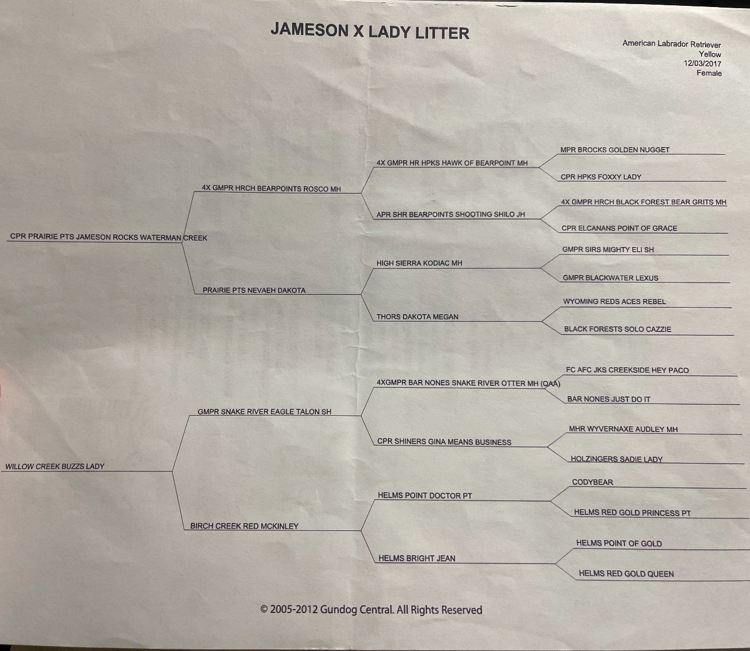
DAM “THIRY HAZELNUT”

